# Setting Up Application Environment

**Create an Account in Sendgrid**

|  |  |
| --- | --- |
| Date | 14 November 2022 |
| Team ID | PNT2022TMID29803 |
| Project Name | Skill and Job Recommender Application |
| Team Members: | Keerthivasan,Gokul,Jeevanandham,Chandra kumar |

# Step 1:

Go to official Sendgrid website: [***https://sendgrid.com/***,](https://sendgrid.com/) then click start for free.



# Step 2:

Then go to Registration Page, you need to give all the details required for creating a

Sendgrid account and finally click create button. The below screenshot will show the registration Process.

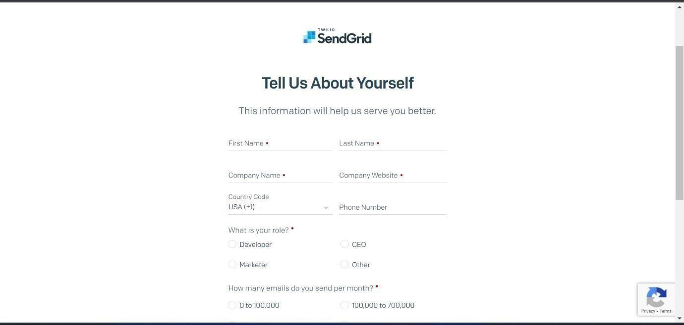

# Step 3:

Then it will redirect you to a home page of your sendgrid account.

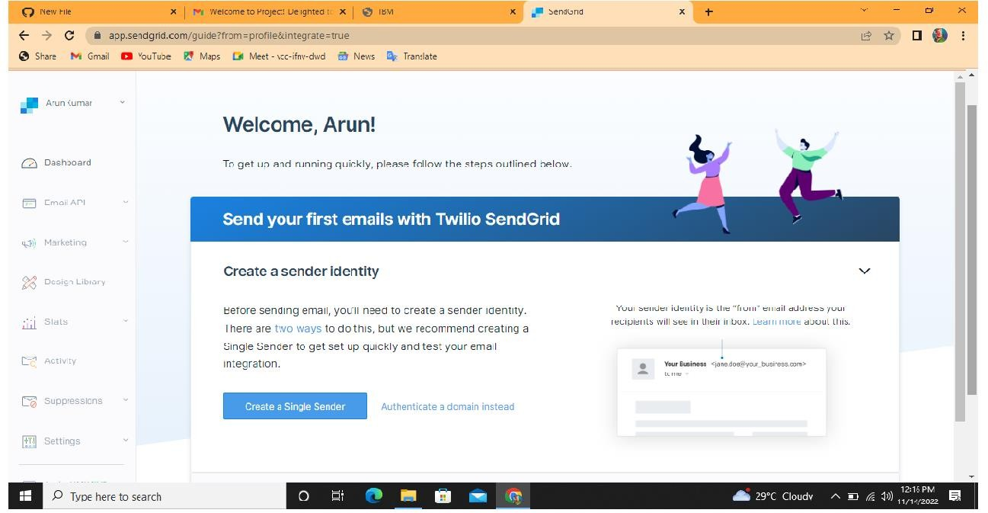

# Step 4:

Finally, you have created your account and now you can access the sendgrid account.